Evaluation: Random Forest
Accuracy: 0.9380530973451328
Precision: 0.9512844977697208
Recall: 0.9380530973451328
F1 Score: 0.9422576382493093
Jaccard Index: 0.9013270398333459
Matthews CorrCoef: 0.9213069141571055
Cohen’s Kappa: 0.9198240054279473
Specificity: 0.9903923150840191
AUC: 1.0
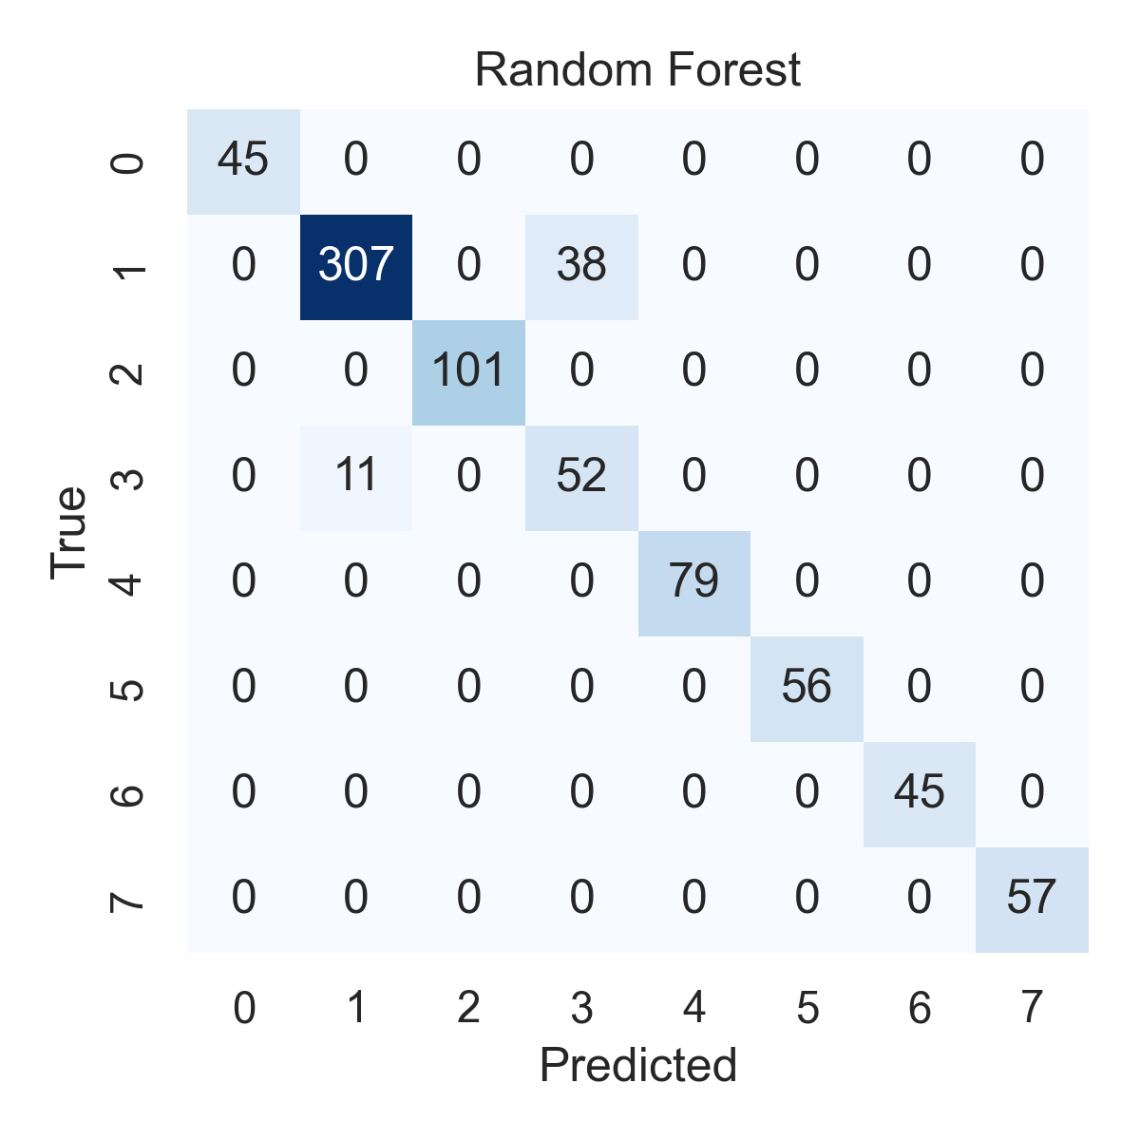

Combined ROC Curves
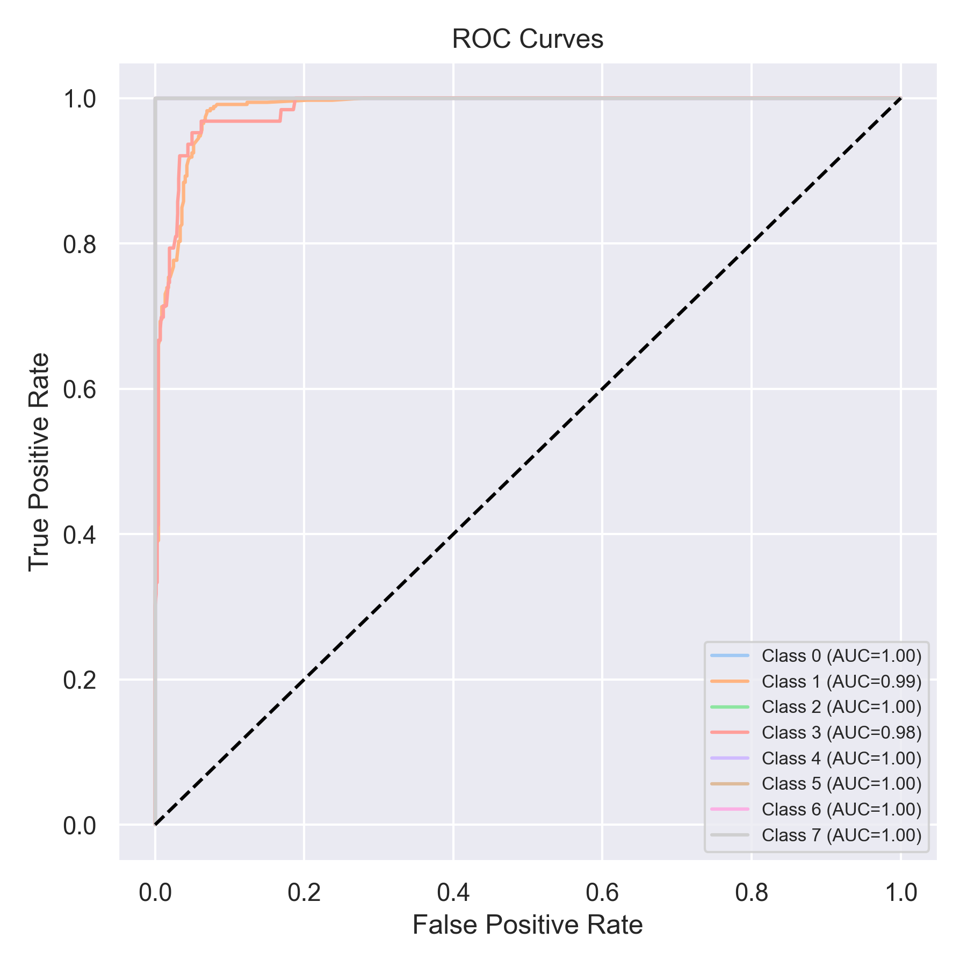

Evaluation: K-Nearest Neighbors
Accuracy: 0.7079646017699115
Precision: 0.7678033481107298
Recall: 0.7079646017699115
F1 Score: 0.7083567754766678
Jaccard Index: 0.55131690443871
Matthews CorrCoef: 0.6611020014702338
Cohen’s Kappa: 0.6450903002497874
Specificity: 0.9584618786017146
AUC: 0.993785553802763
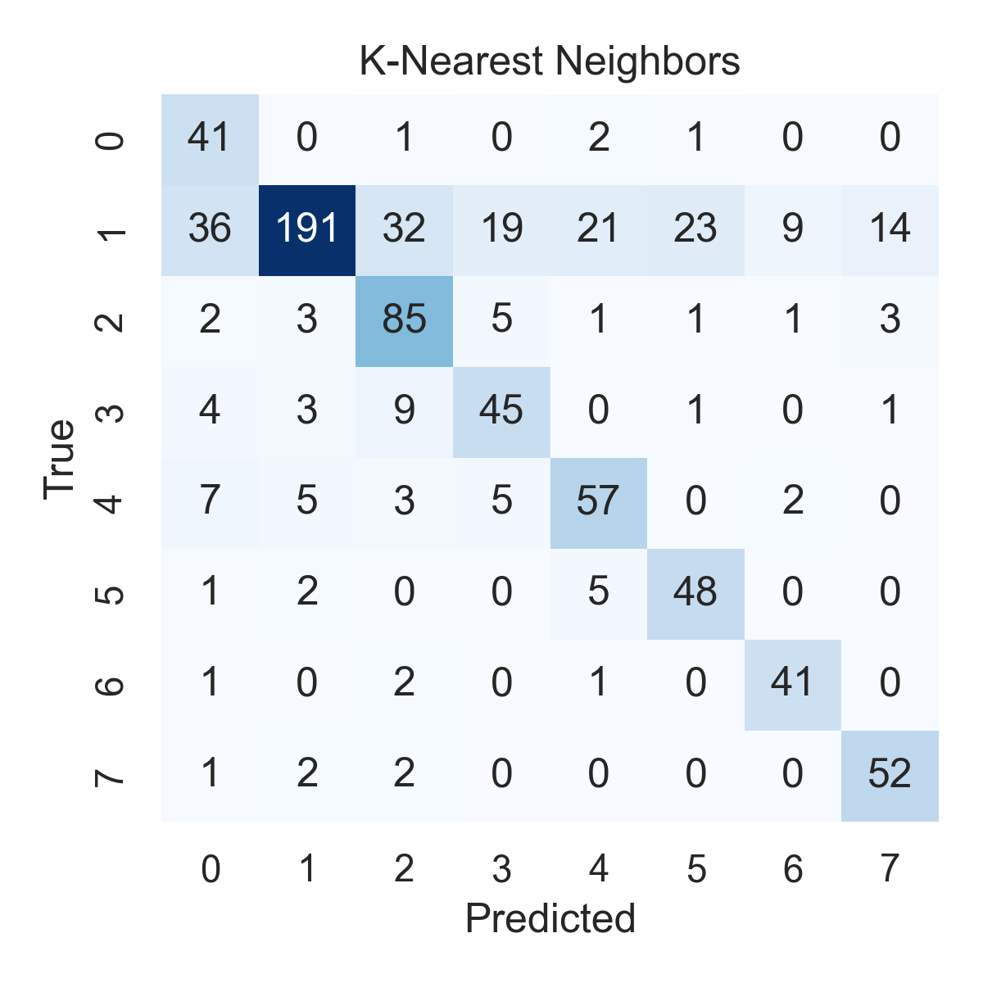

Combined ROC Curves
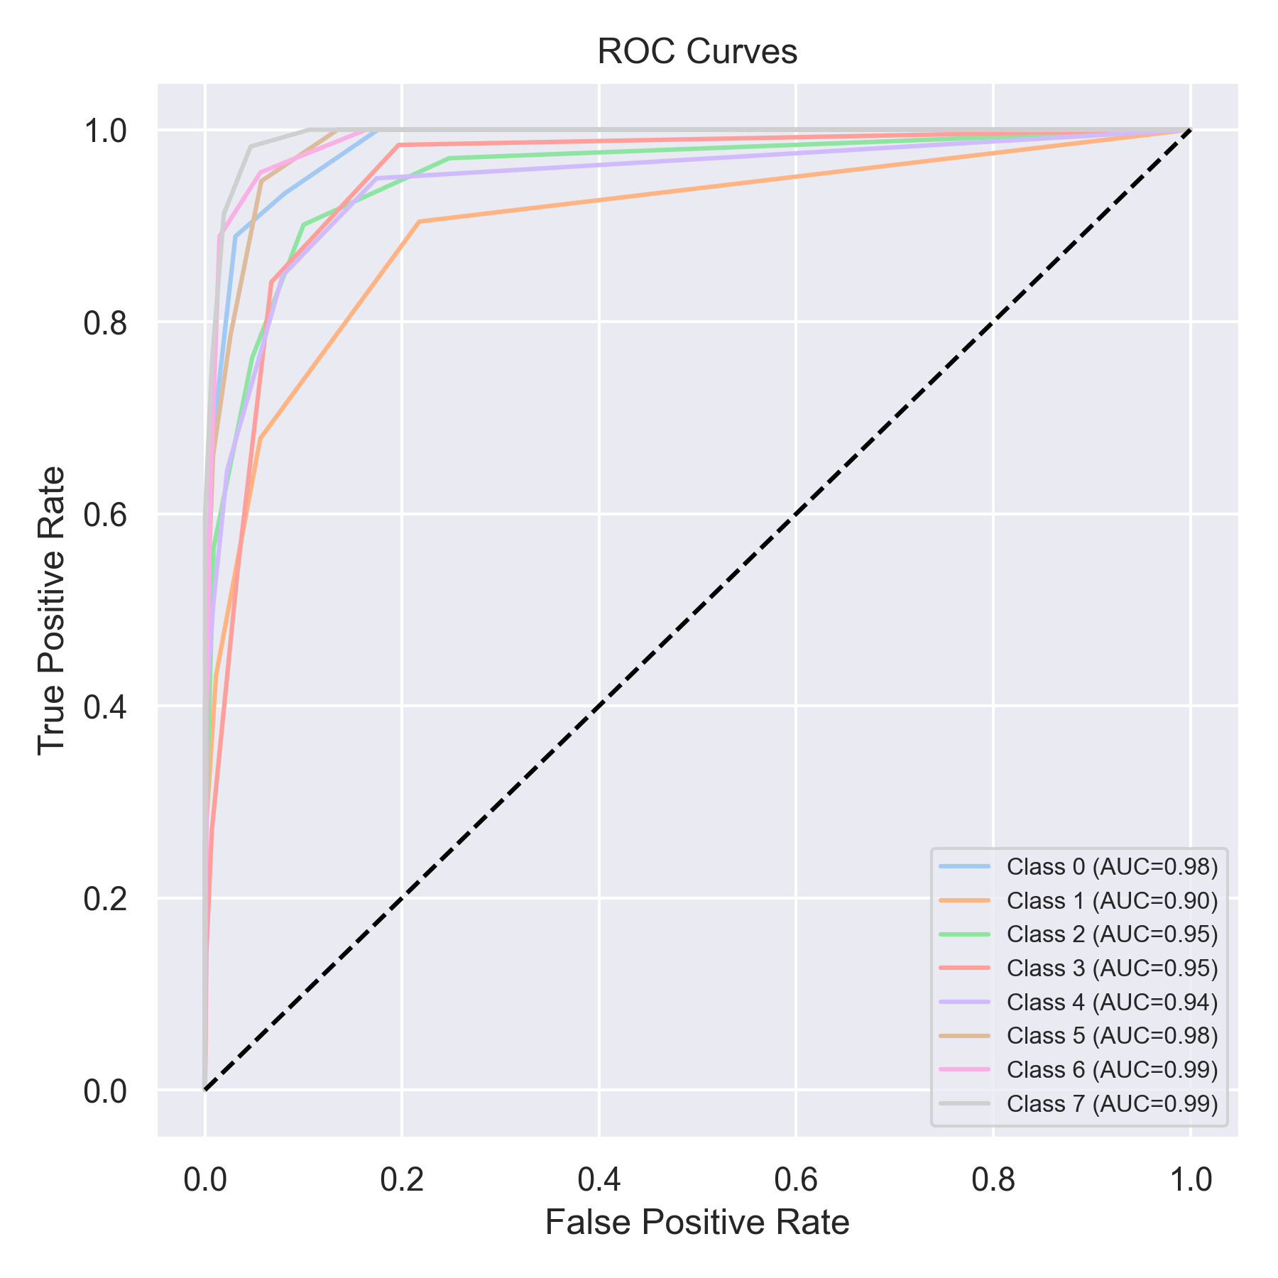

Evaluation: Decision Tree
Accuracy: 0.7522123893805309
Precision: 0.8745134231934324
Recall: 0.7522123893805309
F1 Score: 0.7858830503450903
Jaccard Index: 0.7032346286658371
Matthews CorrCoef: 0.7273579828362616
Cohen’s Kappa: 0.6991286460051622
Specificity: 0.9633063125215592
AUC: 1.0
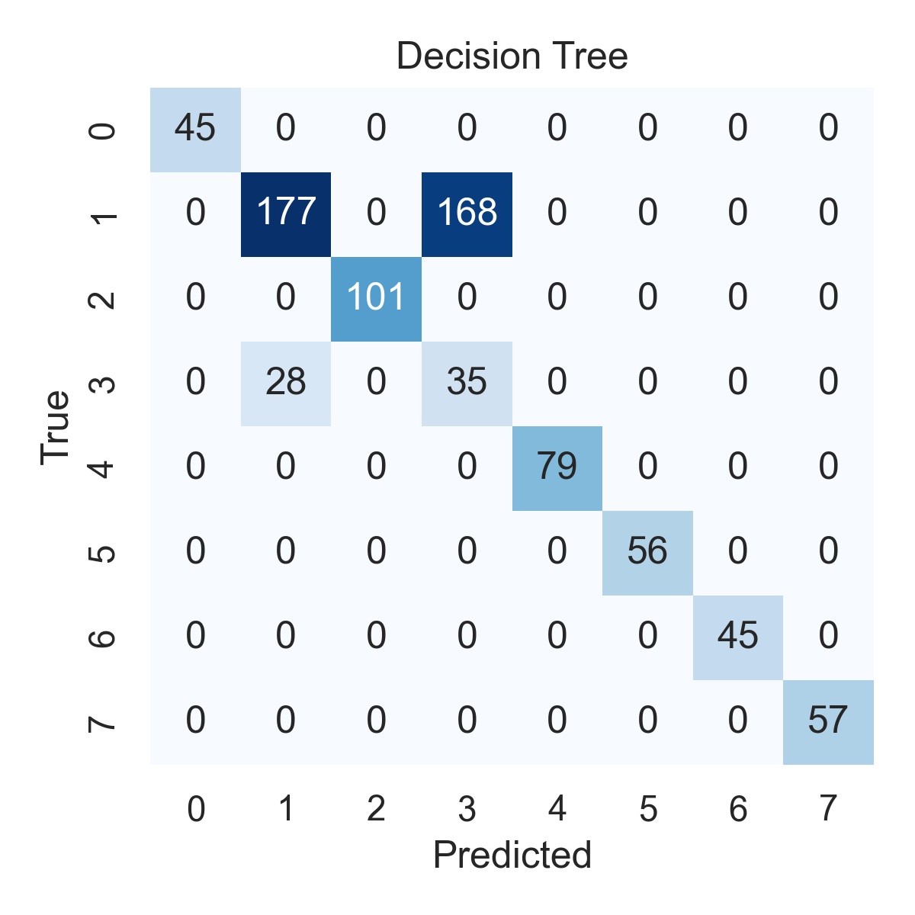

Combined ROC Curves
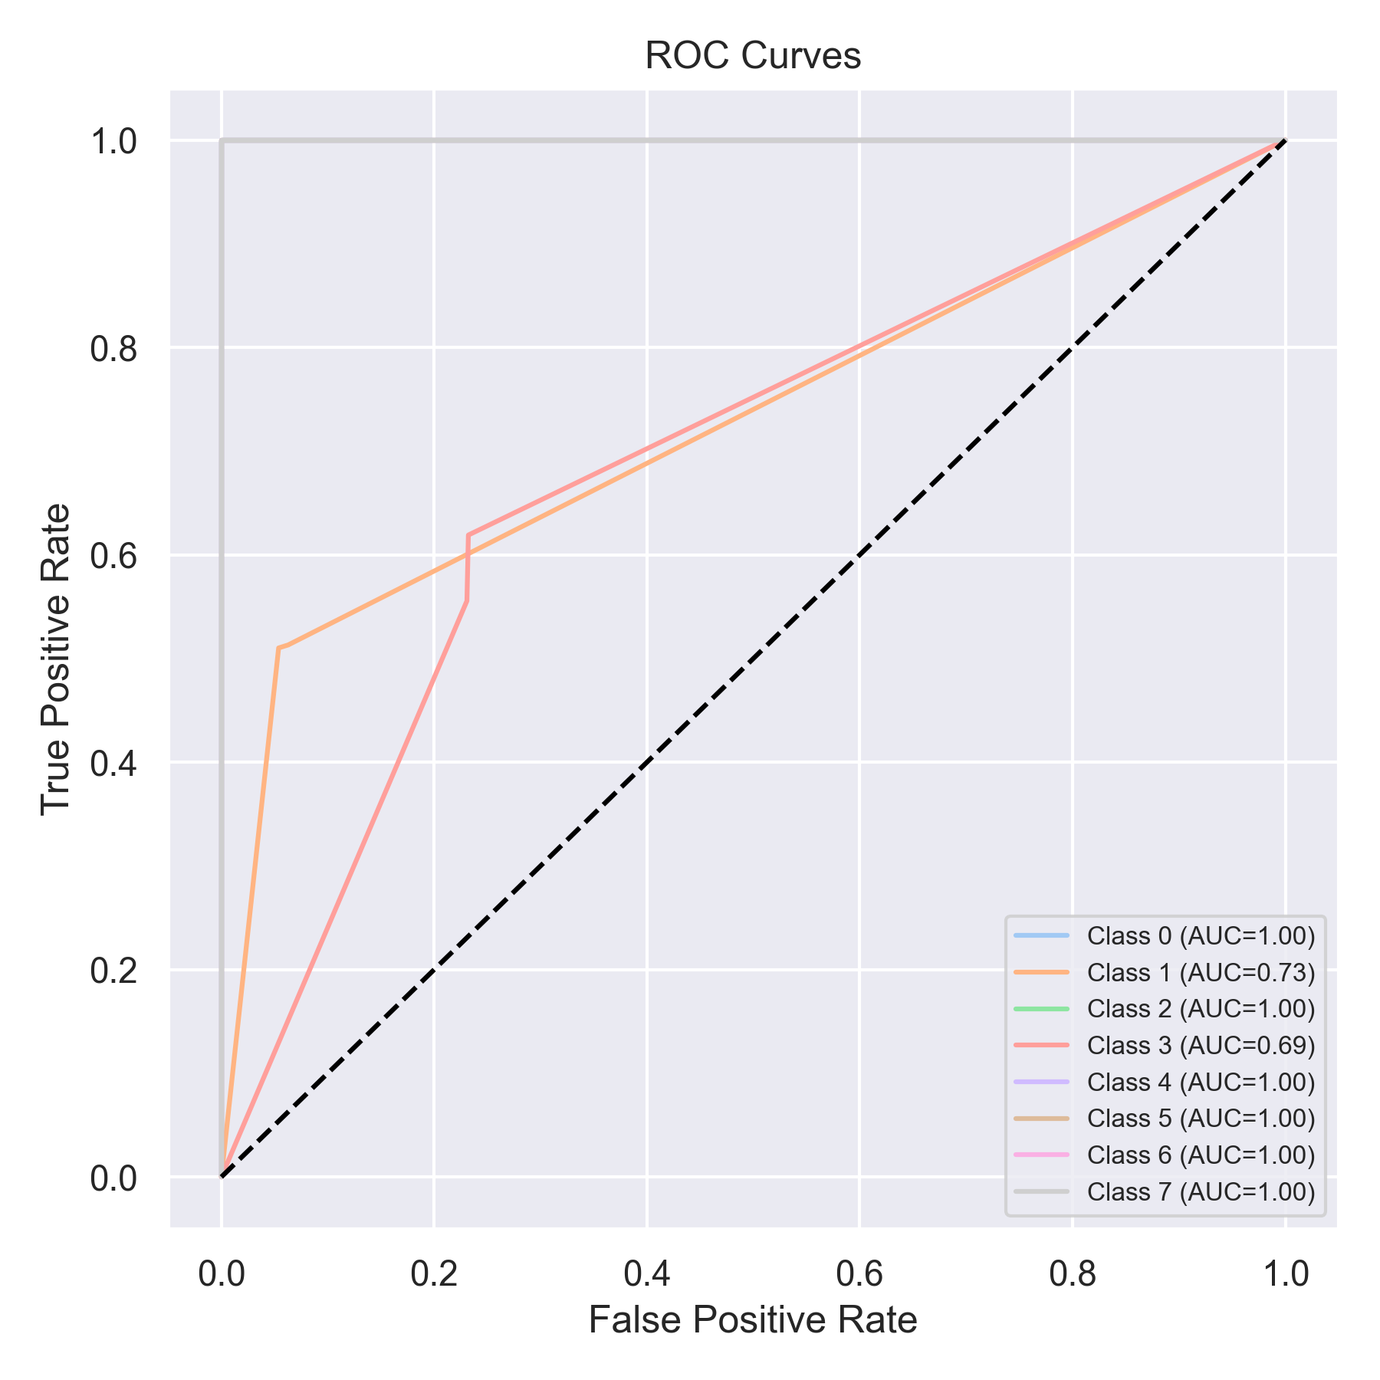

Evaluation: Extra Trees
Accuracy: 0.9797724399494311
Precision: 0.9804382221159312
Recall: 0.9797724399494311
F1 Score: 0.9800246607026968
Jaccard Index: 0.9626615487932012
Matthews CorrCoef: 0.9734993605380453
Cohen’s Kappa: 0.9734640561246954
Specificity: 0.9966013526831913
AUC: 1.0
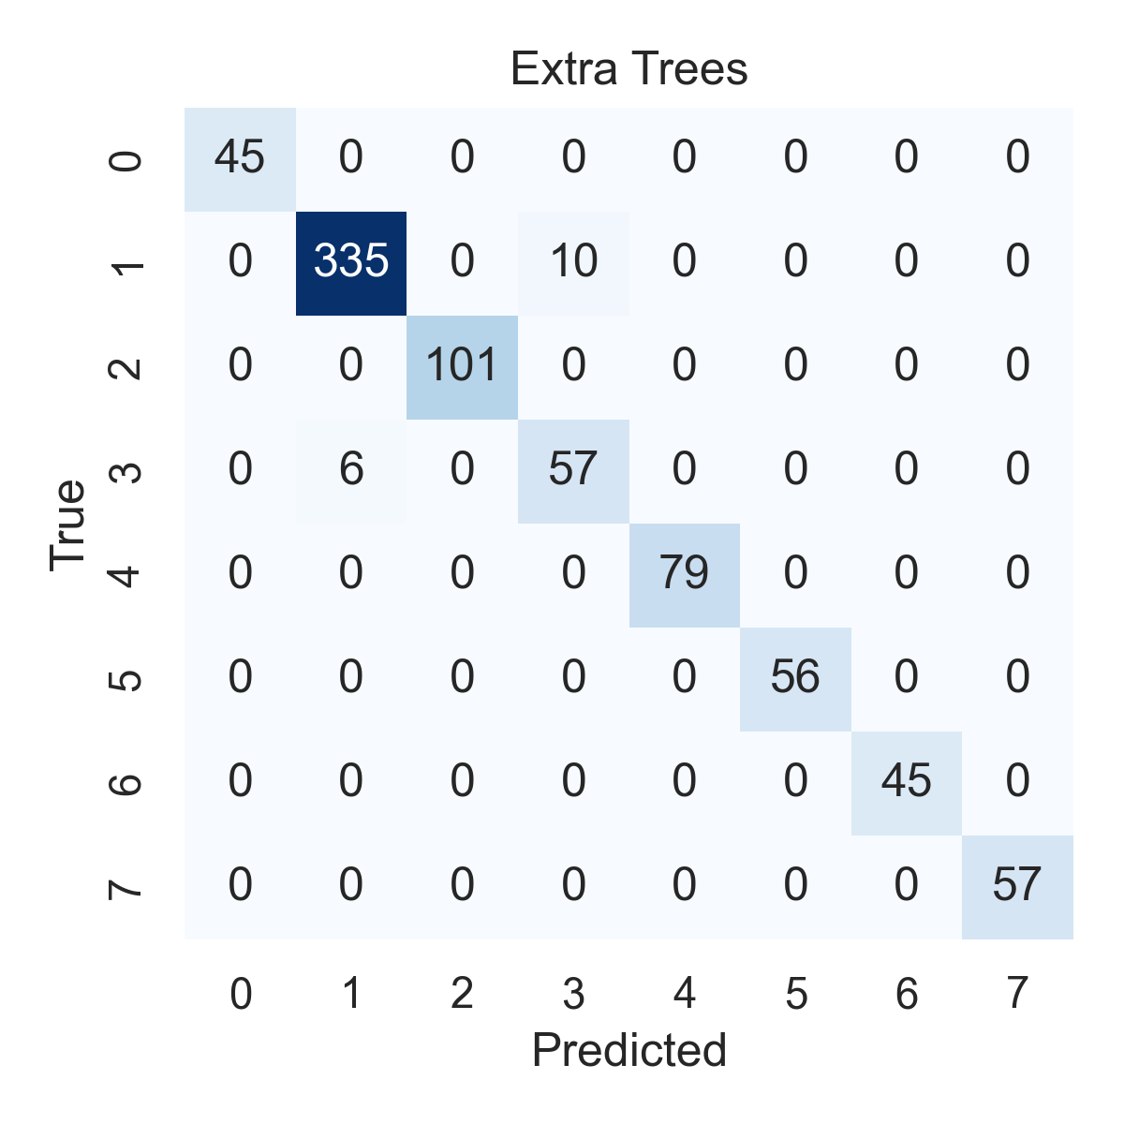

Combined ROC Curves
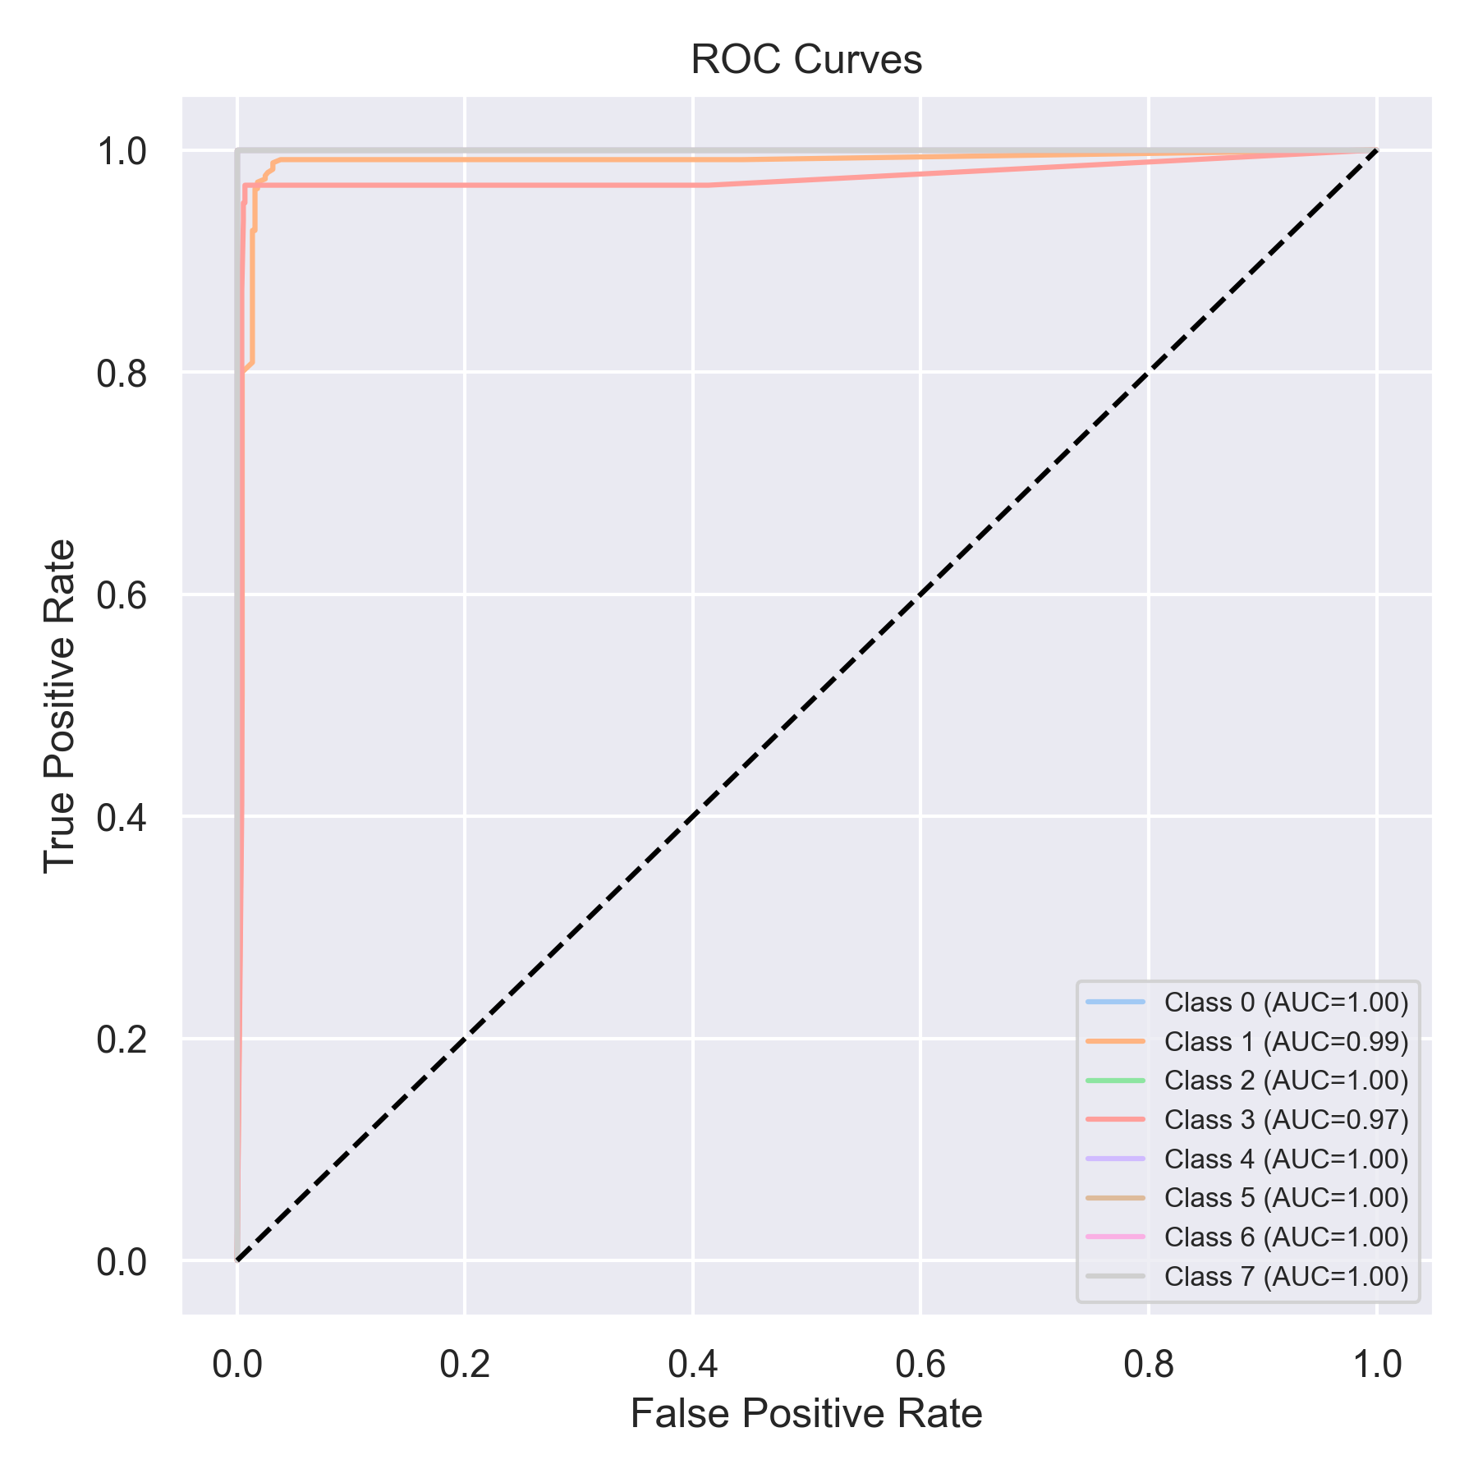

Evaluation: Bagging Classifier
Accuracy: 0.7534766118836915
Precision: 0.879218655526851
Recall: 0.7534766118836915
F1 Score: 0.7860916066578392
Jaccard Index: 0.7022963088790793
Matthews CorrCoef: 0.731629602130753
Cohen’s Kappa: 0.7014909486412317
Specificity: 0.9638078560780279
AUC: 1.0
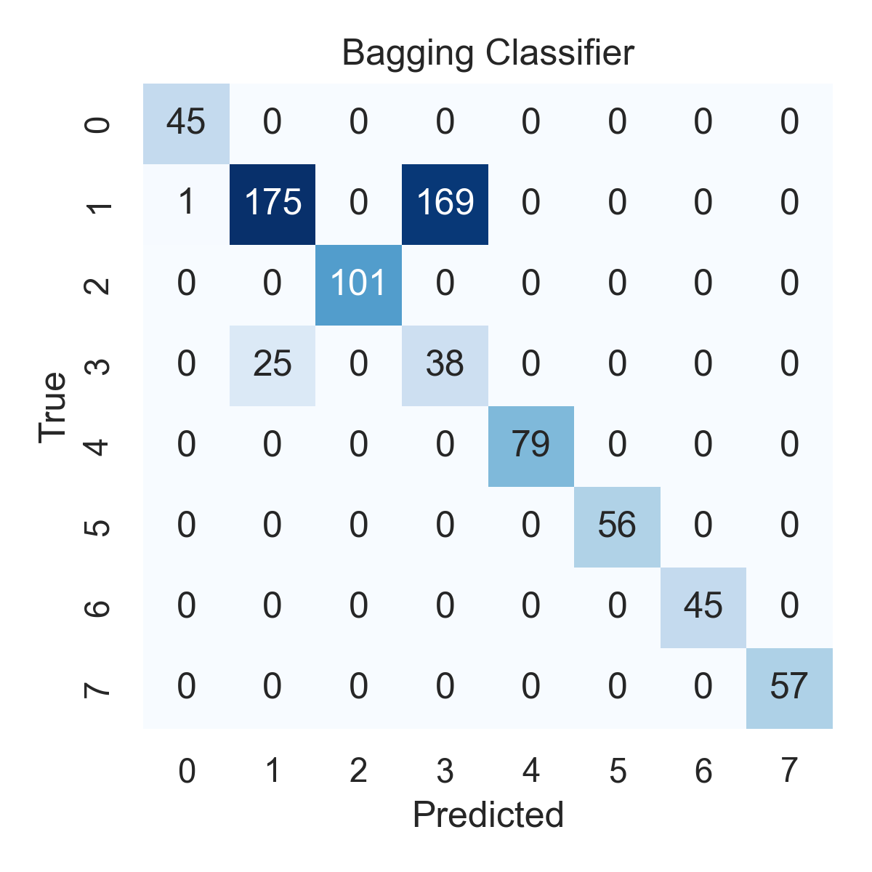

Combined ROC Curves
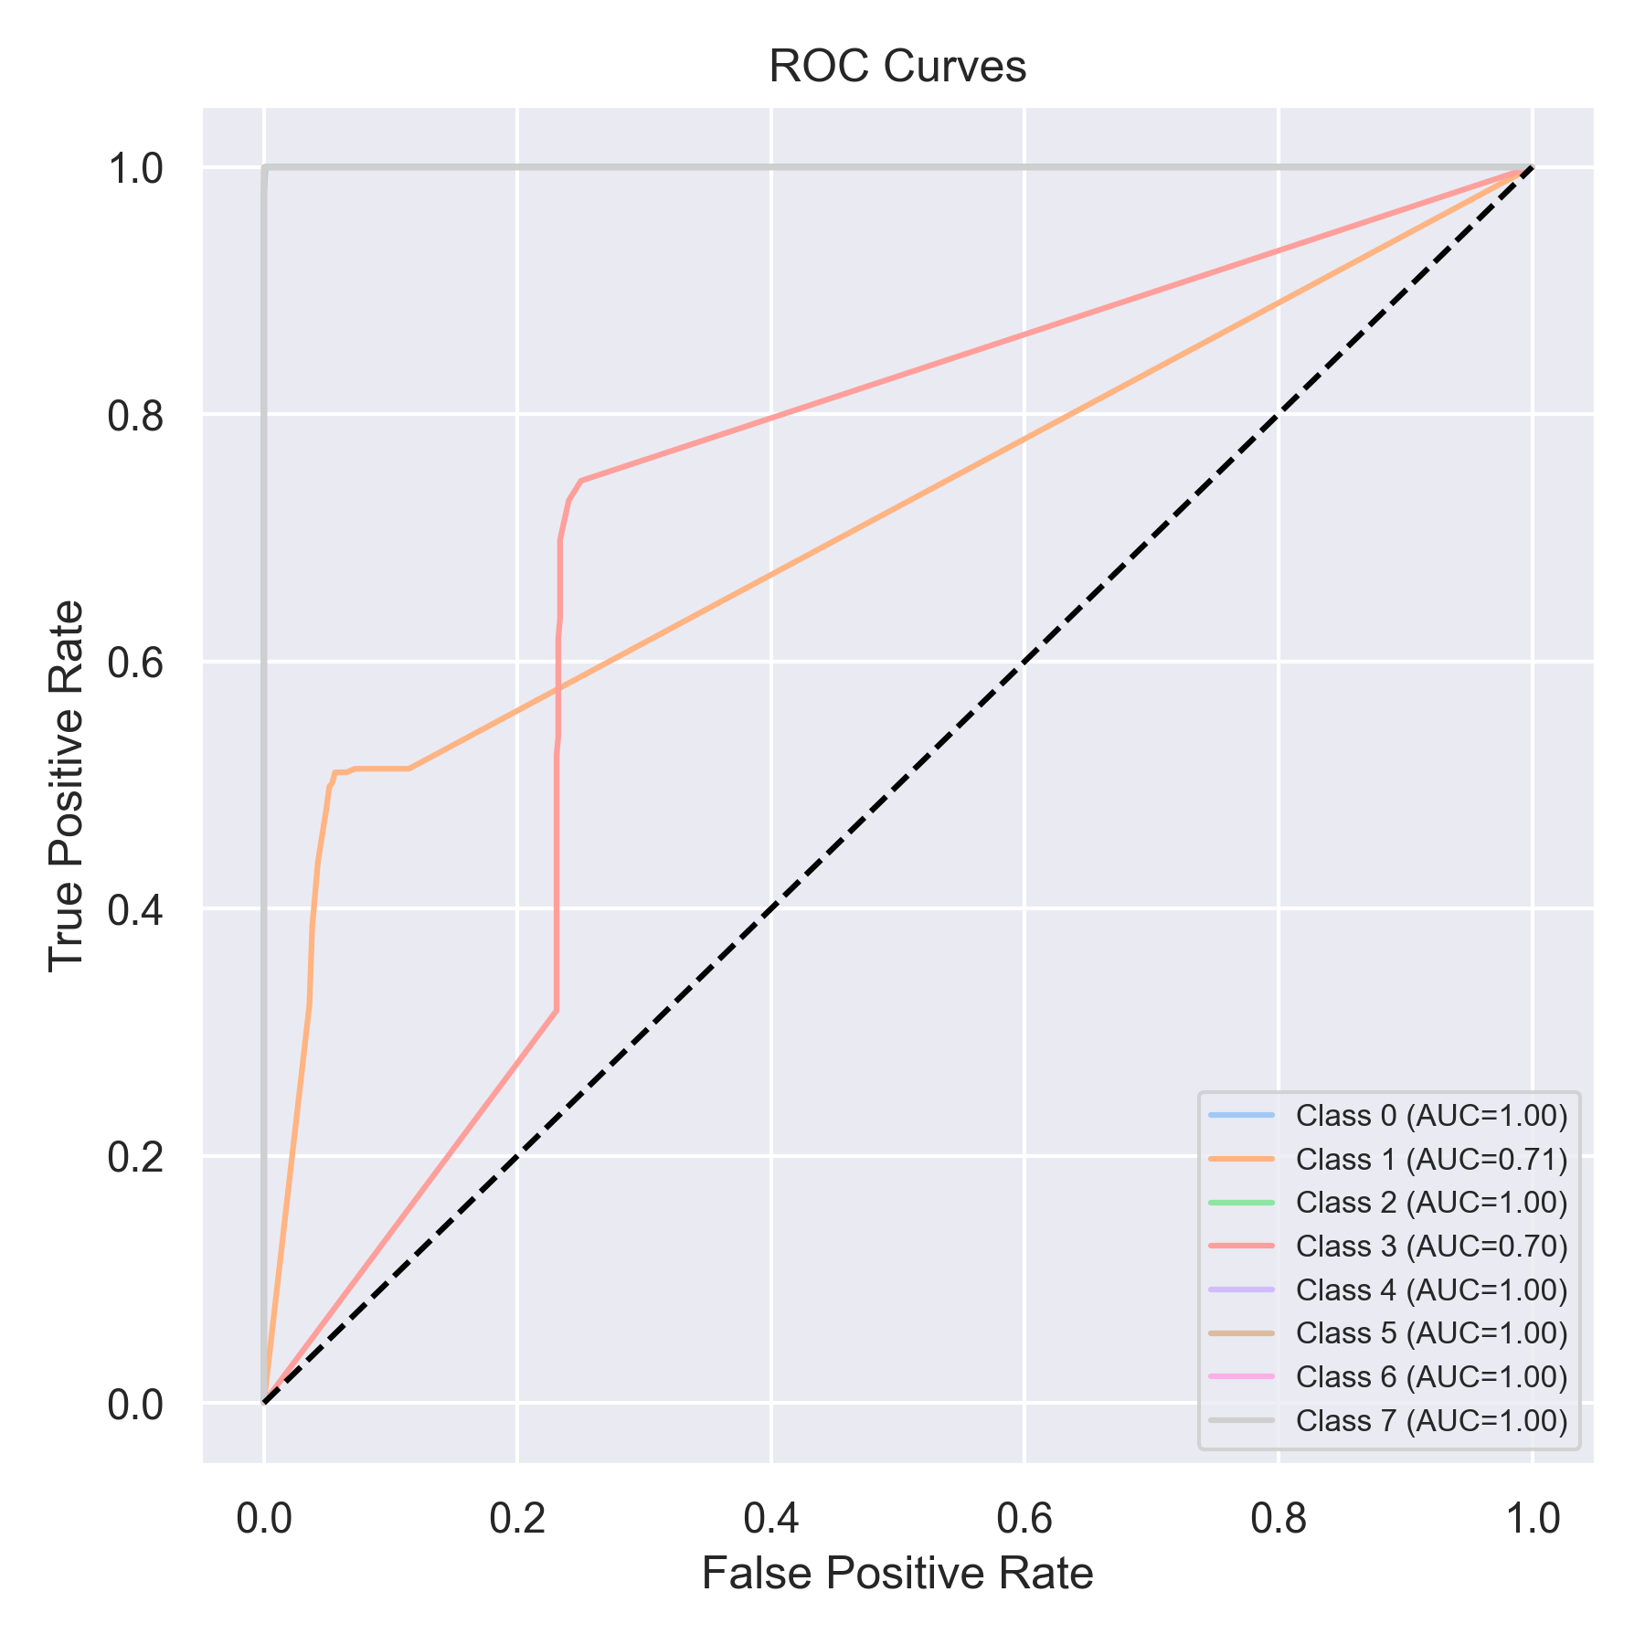

Evaluation: XGBoost
Accuracy: 0.7610619469026548
Precision: 0.8920028068952458
Recall: 0.7610619469026548
F1 Score: 0.7928887686013951
Jaccard Index: 0.7092704026820387
Matthews CorrCoef: 0.7437524116948825
Cohen’s Kappa: 0.7112960287972068
Specificity: 0.9653767616912236
AUC: 1.0
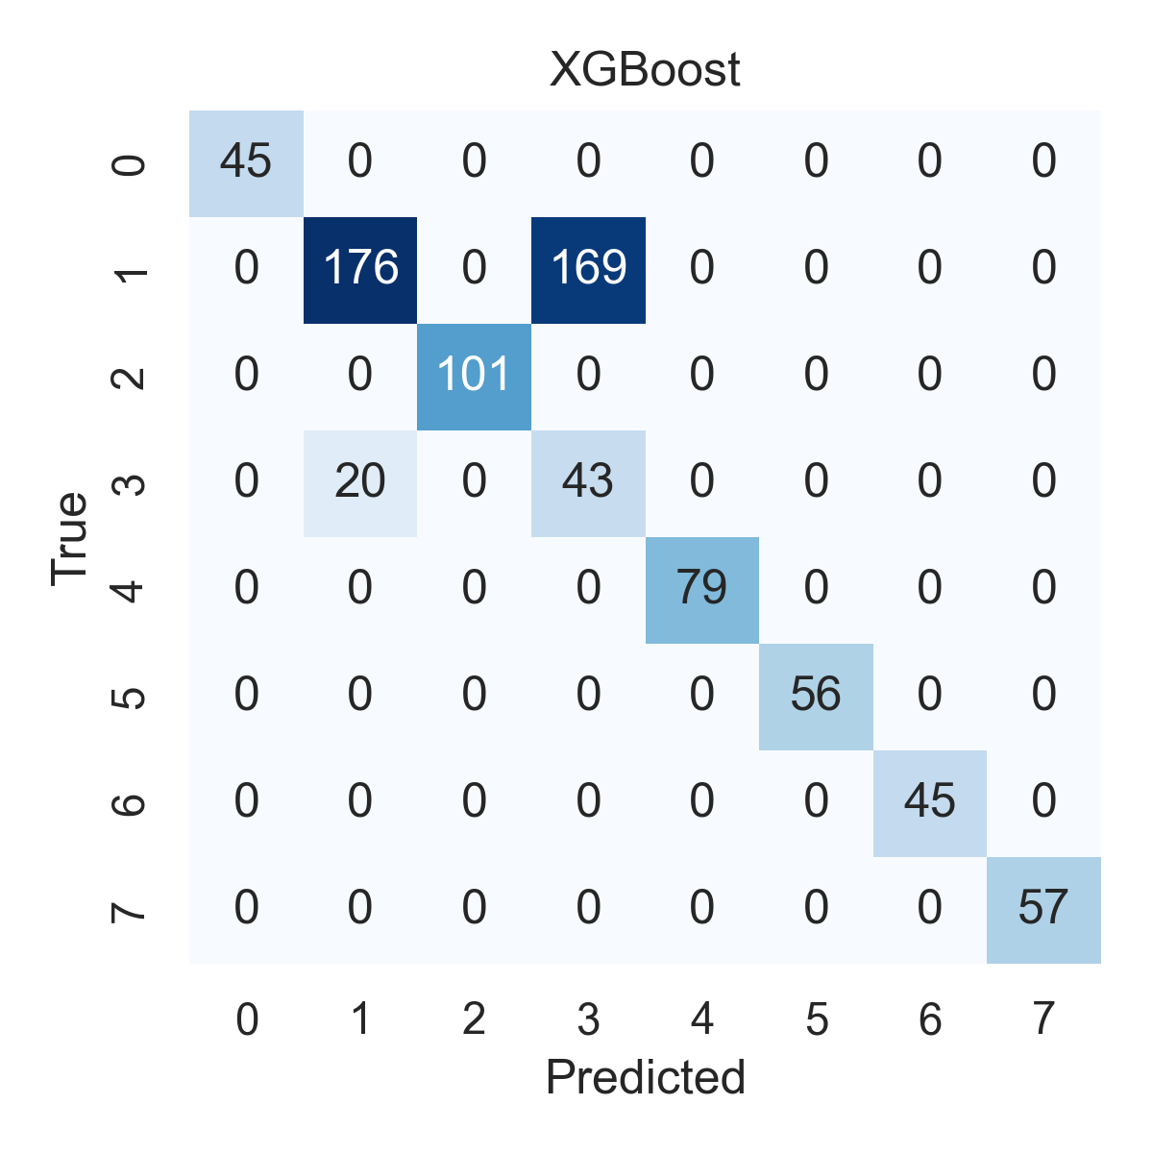

Combined ROC Curves
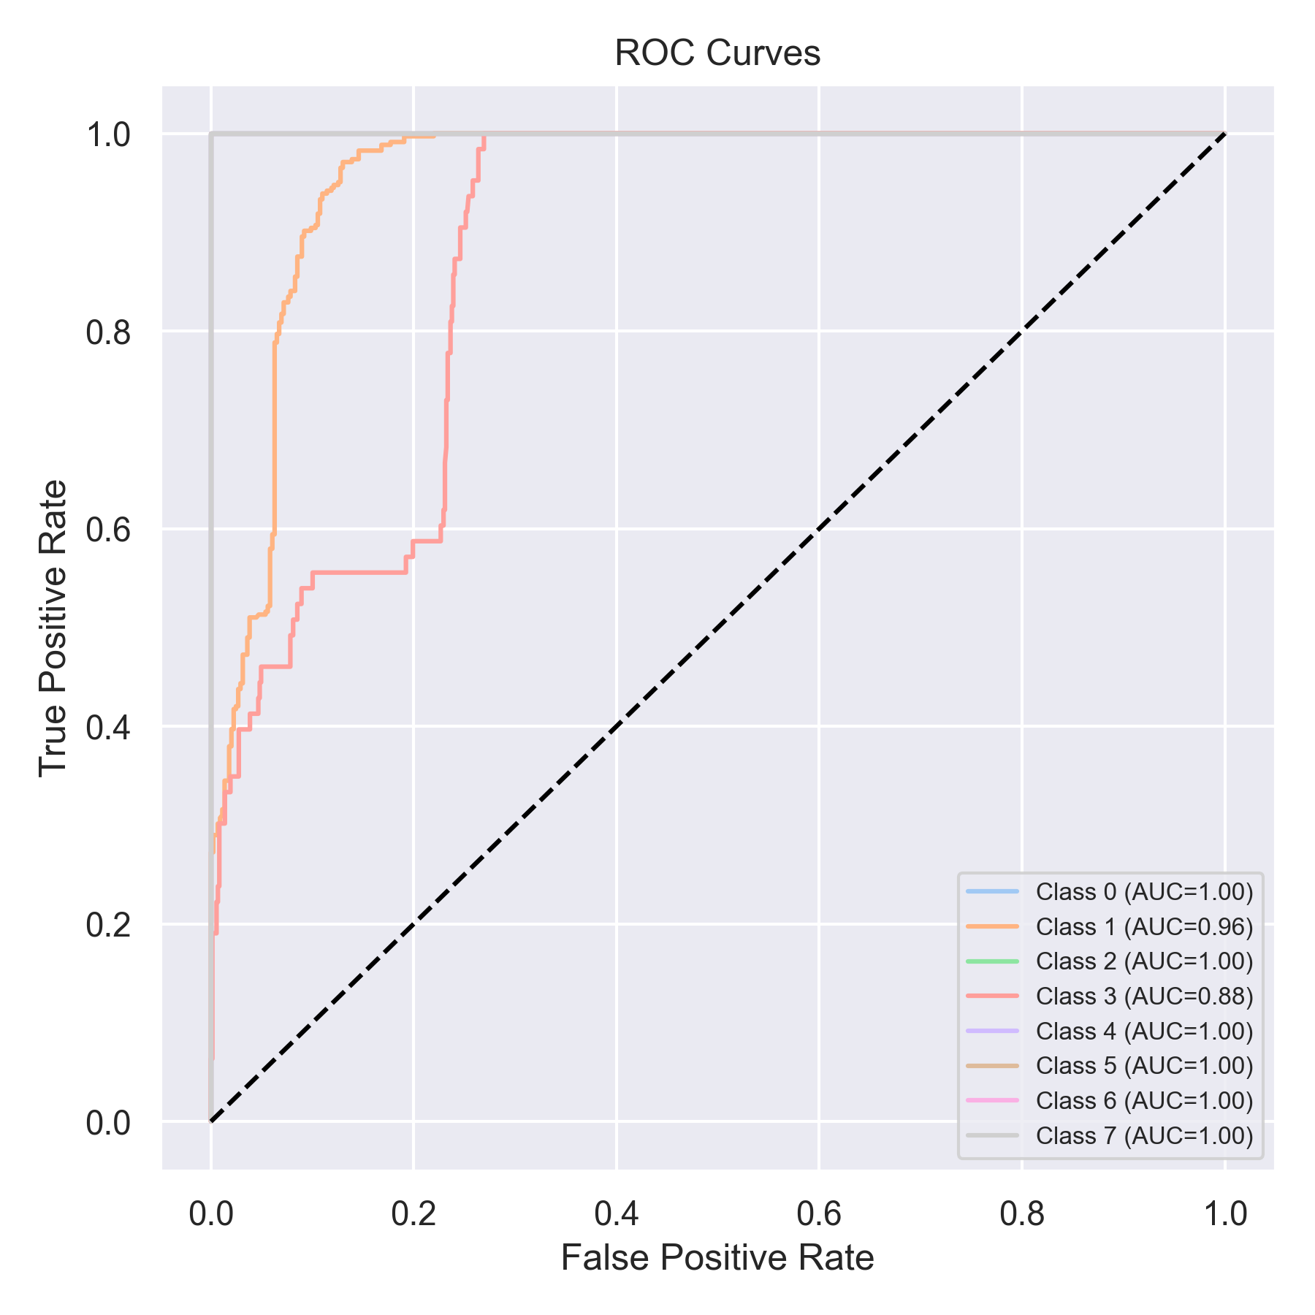

Evaluation: LightGBM
Accuracy: 0.8002528445006322
Precision: 0.8990449662703858
Recall: 0.8002528445006322
F1 Score: 0.8279426192169611
Jaccard Index: 0.7487933928830489
Matthews CorrCoef: 0.7753197727585143
Cohen’s Kappa: 0.7542328552157036
Specificity: 0.9705909981274331
AUC: 1.0
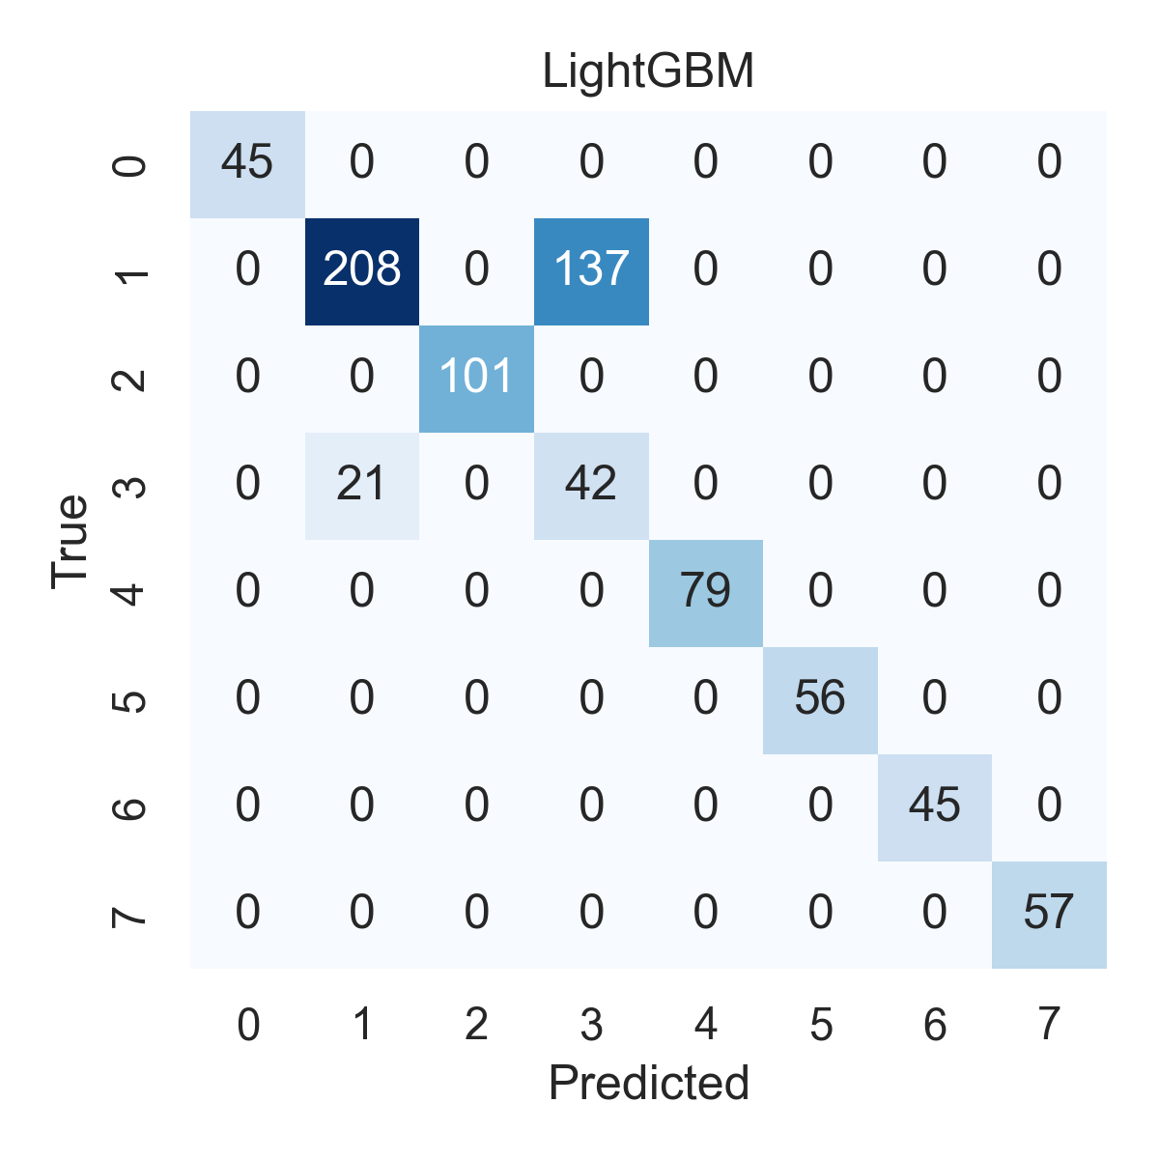

Combined ROC Curves
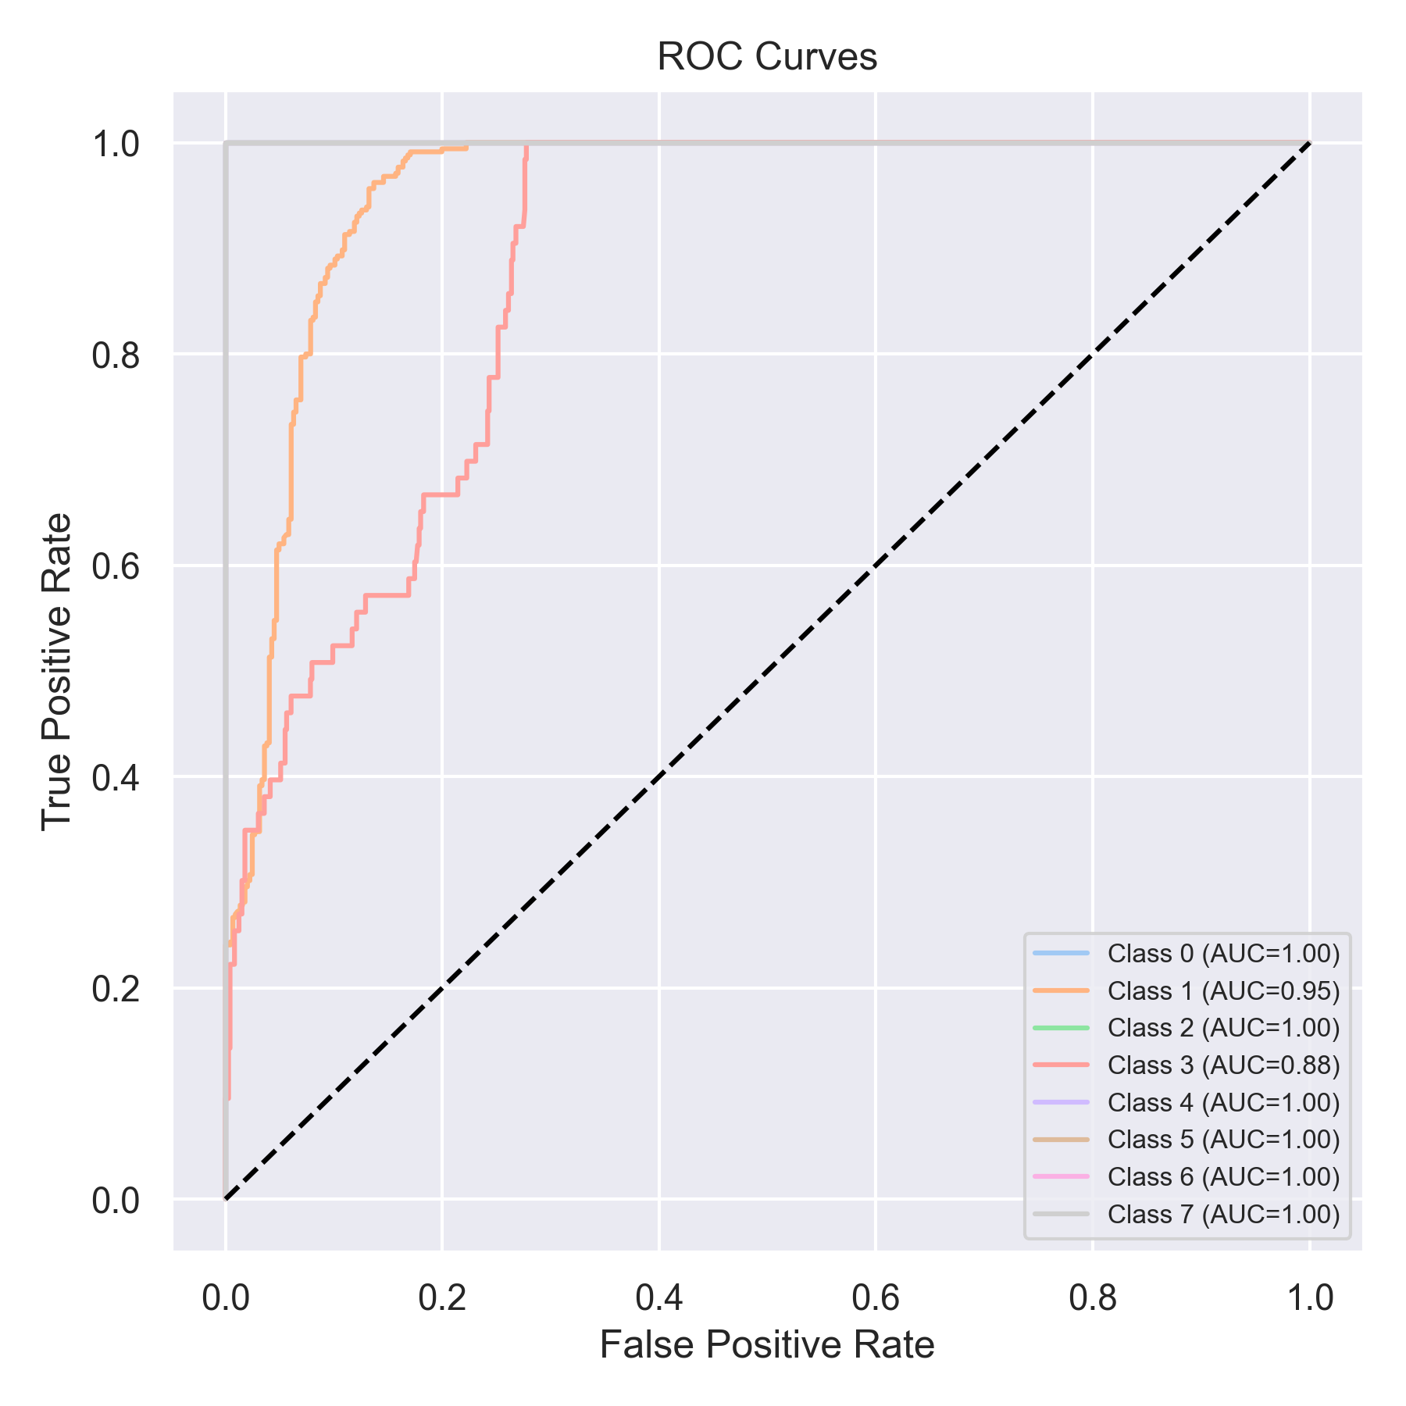

Evaluation: CatBoost
Accuracy: 0.056890012642225034
Precision: 0.003236473538432524
Recall: 0.056890012642225034
F1 Score: 0.006124522892105566
Jaccard Index: 0.003236473538432524
Matthews CorrCoef: 0.0
Cohen’s Kappa: 0.0
Specificity: 0.875
AUC: 1.0
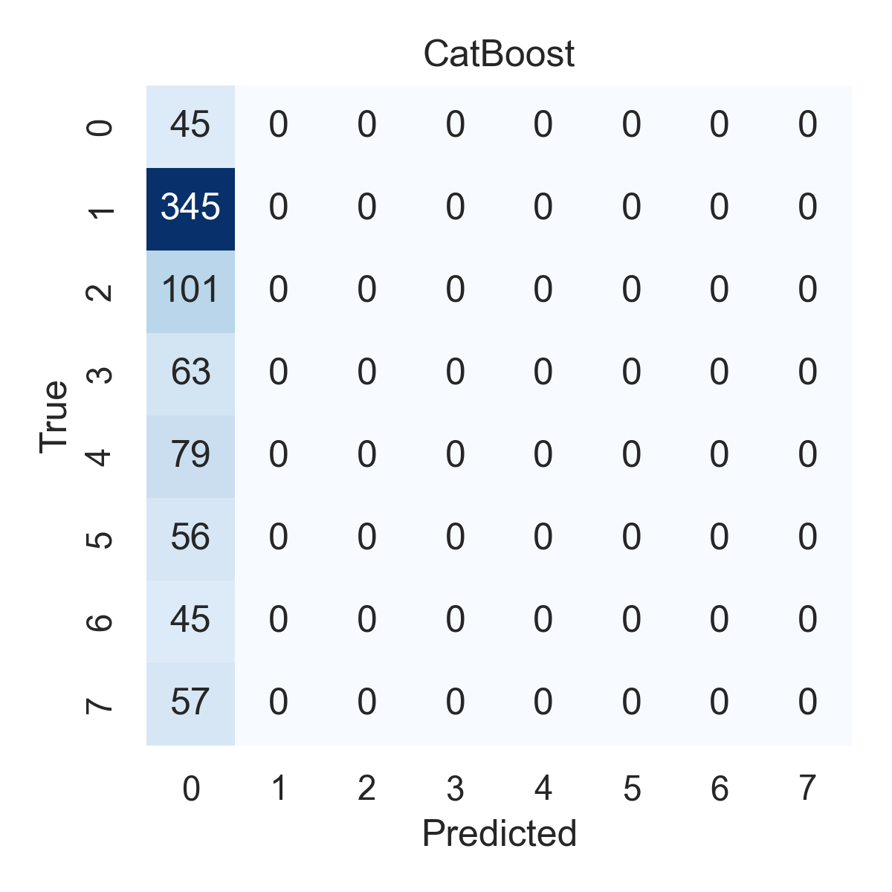

Combined ROC Curves
